**Lab Practical #13:**

To develop network using distance vector routing protocol and link state routing protocol.

**Practical Assignment #13:**

1. **C/Java Program: Distance Vector Routing Algorithm using Bellman Ford's Algorithm.**

**import java.util.*;**

**class Router {**

**int id;**

**int[] distance;**

**int[] nextHop;**

**List<Integer> neighbors;**

**public Router(int id, int numRouters) {**

**this.id = id;**

**this.distance = new int[numRouters];**

**this.nextHop = new int[numRouters];**

**this.neighbors = new ArrayList<>();**

**for (int i = 0; i < numRouters; i++) {**

**if (i == id) {**

**distance[i] = 0;**

**} else {**

**distance[i] = Integer.MAX_VALUE;**

**}**

**nextHop[i] = -1;**

**}**

**}**

**public void addNeighbor(int neighbor) {**

**neighbors.add(neighbor);**

**}**

**}**

**public class DistanceVectorRouting {**

**private static final int INFINITY = Integer.MAX_VALUE;**

**private int numRouters;**

**private Router[] routers;**

**private int[][] costMatrix;**

**public DistanceVectorRouting(int numRouters) {**

**this.numRouters = numRouters;**

**routers = new Router[numRouters];**

**costMatrix = new int[numRouters][numRouters];**

**for (int i = 0; i < numRouters; i++) {**

**routers[i] = new Router(i, numRouters);**

**for (int j = 0; j < numRouters; j++) {**

**costMatrix[i][j] = (i == j) ? 0 : INFINITY;**

**}**

**}**

**}**

**public void addLink(int from, int to, int cost) {**

**costMatrix[from][to] = cost;**

**costMatrix[to][from] = cost;**

**routers[from].addNeighbor(to);**

**routers[to].addNeighbor(from);**

**}**

**public void bellmanFord() {**

**boolean updated;**

**for (int step = 0; step < numRouters - 1; step++) {**

**updated = false;**

**for (int i = 0; i < numRouters; i++) {**

**Router router = routers[i];**

**for (int neighbor : router.neighbors) {**

**for (int dest = 0; dest < numRouters; dest++) {**

**if (router.distance[dest] > routers[neighbor].distance[dest]**

**+ costMatrix[i][neighbor]) {**

**router.distance[dest] = routers[neighbor].distance[dest]**

**+ costMatrix[i][neighbor];**

**router.nextHop[dest] = neighbor;**

**updated = true;**

**}**

**}**

**}**

**if (!updated) {**

**break;**

**}**

**}**

**}**

**}**

**public void printRoutingTable() {**

**System.out.println("Routing Tables:");**

**for (Router router : routers) {**

**System.out.println("\nRouter " + router.id + ":");**

**System.out.println("Destination\tDistance\tNext Hop");**

**for (int i = 0; i < numRouters; i++) {**

**System.out.println(i + "\t\t" + (router.distance[i] == INFINITY ?**

**"Inf" : router.distance[i]) + "\t\t" + (router.nextHop[i] == -1 ? "-" :**

**router.nextHop[i]));**

**}**

**}**

**}**

**public static void main(String[] args) {**

**int numRouters = 4;**

**DistanceVectorRouting dvr = new DistanceVectorRouting(numRouters);**

**dvr.addLink(0, 1, 1);**

**dvr.addLink(0, 2, 4);**

**dvr.addLink(1, 2, 2);**

**dvr.addLink(1, 3, 6);**

**dvr.addLink(2, 3, 3);**

**dvr.bellmanFord();**

**dvr.printRoutingTable();**

**}**

**}**

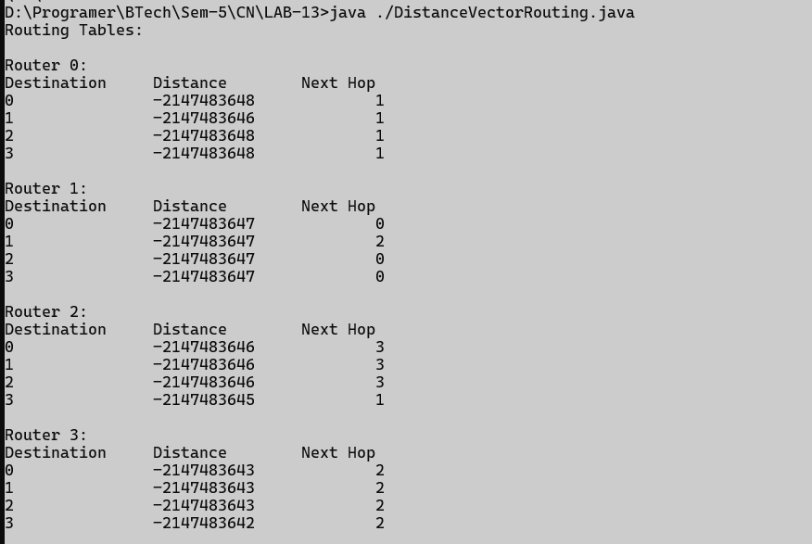

1. **C/Java Program: Link state routing algorithm.**

**import java.util.Arrays;**

**public class LinkStateRouting {**

**static final int V = 6;**

**static final int INF = Integer.MAX_VALUE;**

**int minDistance(int dist[], boolean visited[]) {**

**int min = INF, min_index = -1;**

**for (int v = 0; v < V; v++) {**

**if (!visited[v] && dist[v] <= min) {**

**min = dist[v];**

**min_index = v;**

**}**

**}**

**return min_index;**

**}**

**void printSolution(int dist[]) {**

**System.out.println("Vertex \t Distance from Source");**

**for (int i = 0; i < V; i++) {**

**System.out.println(i + " \t\t " + dist[i]);**

**}**

**}**

**void dijkstra(int graph[][], int src) {**

**int dist[] = new int[V];**

**boolean visited[] = new boolean[V];**

**Arrays.fill(dist, INF);**

**Arrays.fill(visited, false);**

**dist[src] = 0;**

**for (int count = 0; count < V - 1; count++) {**

**int u = minDistance(dist, visited);**

**visited[u] = true;**

**for (int v = 0; v < V; v++) {**

**if (!visited[v] && graph[u][v] != 0 && dist[u] != INF && dist[u] +**

**graph[u][v] < dist[v]) {**

**dist[v] = dist[u] + graph[u][v];**

**}**

**}**

**}**

**printSolution(dist);**

**}**

**public static void main(String[] args) {**

**int graph[][] = {**

**{ 0, 2, INF, 1, INF, INF },**

**{ 2, 0, 3, 2, INF, INF },**

**{ INF, 3, 0, INF, 7, 4 },**

**{ 1, 2, INF, 0, 5, INF },**

**{ INF, INF, 7, 5, 0, 6 },**

**{ INF, INF, 4, INF, 6, 0 }**

**};**

**LinkStateRouting lsr = new LinkStateRouting();**

**lsr.dijkstra(graph, 0);**

**}**

**}**

